The Philippine peso finished strongly in 2017 with a slight 0.5% depreciation and moved within a tighter band compared to other Asian currencies. This is due to sustained strong macroeconomic fundamentals backed by prudent fiscal and monetary policy and continuing economic reforms. This occurred as the legislature passed the first package of tax reforms, the BSP adopted foreign exchange liberalization measures*/ and the Fed continued monetary policy normalization.

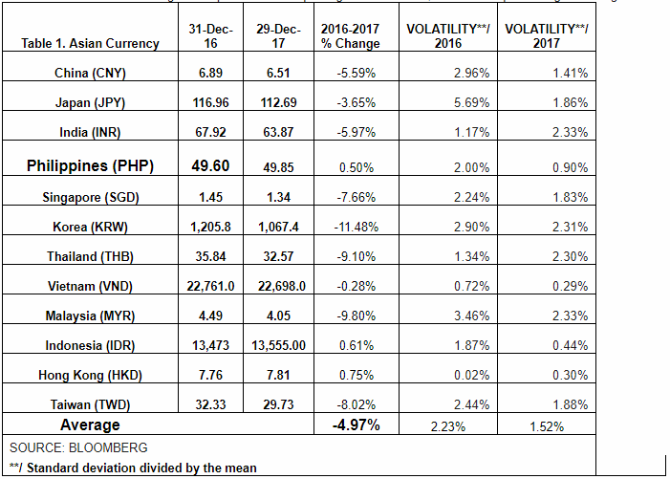
The peso avoided hefty appreciation that occurred elsewhere in Asia and boosted export competitiveness amid the recovery of global markets. The 12 Asian currencies appreciated by almost 5% in stark contrast to three currencies that depreciated slightly. The biggest depreciation was experienced by the HK dollar (0.75%), followed by the Indonesian rupiah (0.61%) and lastly, the Philippine peso (0.5%).
Volatility measures indicate that the peso was among the four Asian currencies which moved within the tightest range. The deviation from the mean averaged 0.9% compared with the 1.5% Asian average. The most stable were the Vietnamese dong (0.29%, HK dollar (0.3%), Indonesian rupiah (0.44%) and the Philippine peso (0.9%).
DOF View
Sustaining the country’s good macroeconomic fundamentals is essential to maintaining stable currency markets. Likewise, reform programs (e.g., forex liberalization) create an environment more beneficial to economic growth.

a. Increase in the amount of FX that Philippine residents may purchase from the banking system without supporting documentation (other than an application to purchase FX) for legitimate transactions from USD120,000 to USD500,000 (for individuals) and USD1 million
(for corporates).
This policy aims to enhance and further facilitate access to FX of both individuals and corporates for legitimate non-trade current account transactions.
b. Allowing of the deposit by Philippine residents of FX purchased from banks for certain underlying transactions (such as for travel abroad and payment of certain obligations to non-residents) into their Foreign Currency Deposit Unit (FCDU) accounts, prior to outward remittance to the intended non-resident beneficiaries.
This shall provide residents with greater flexibility in managing their cash flows as well as provide greater ease in transacting in FX.
c. Lifting of the prohibition on the sale of FX by banks and their forex corporations for resident-to-resident transactions.
This measure will facilitate payment by residents of obligations to their resident counterparties and allow further diversification of residents’ investments.
d. Lifting of prior BSP approval and registration requirements for private sector loans to be obtained from FCDUs/Expanded FCDUs of banks
This is in line with the BSP’s thrust to facilitate access of the private sector to bank financing.
The Board also approved the increase in the amount of legal tender Philippine currency that may be brought into/out of the country from PHP10,000 to PHP50,000. This intends to provide greater convenience to travelers to and from the Philippines, and allow settlement of obligations in jurisdictions outside the Philippines where the Philippine Peso is accepted as a currency of settlement.
Source: BSP Website

